AVERAGES
Pearson Edexcel - Tuesday 21 May 2019 - Paper 1 (Non-Calculator) Foundation Tier

Pearson Edexcel – Specimen 1 - Paper 2 (Calculator) Foundation Tier

OCR November 09 November 2020- Morning (Calculator) Foundation Tier

OCR Tuesday 5 November 2019 – Morning (Calculator) Foundation Tier
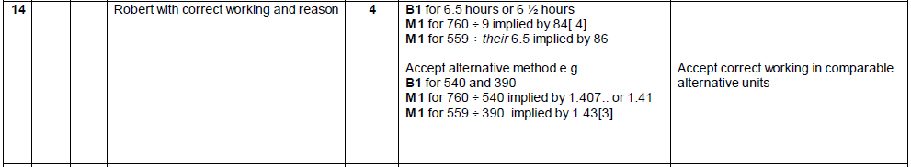

OCR Thursday 07 November 2019- Morning (Non-Calculator) Foundation Tier
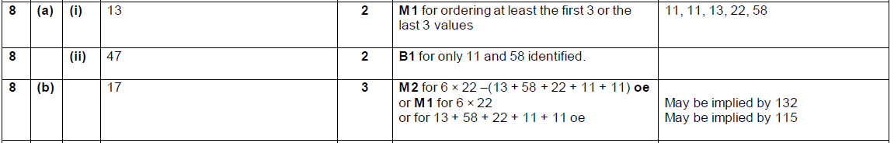

OCR Tuesday 21 May 2019 – Morning (Calculator) Foundation Tier

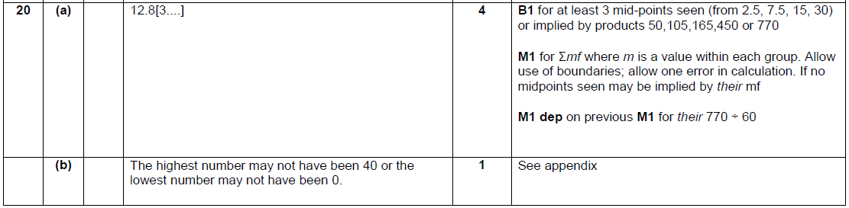

OCR Thursday 8 November 2018 – Morning (Non-Calculator) Foundation Tier
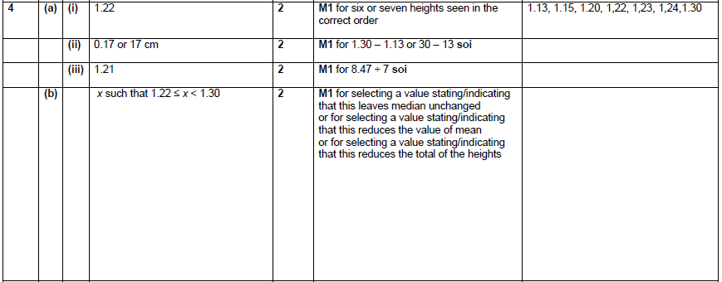

OCR Monday 12 November 2018 – Morning (Calculator) Foundation Tier
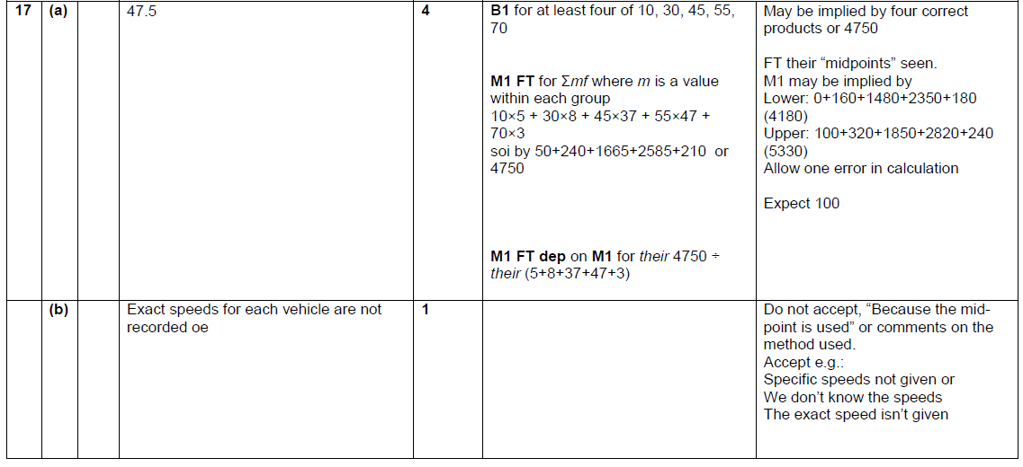

OCR Monday 24 May 2018 – Morning (Calculator) Foundation Tier
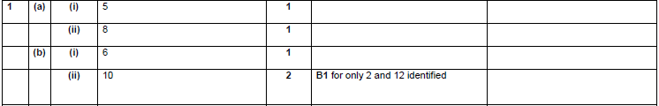

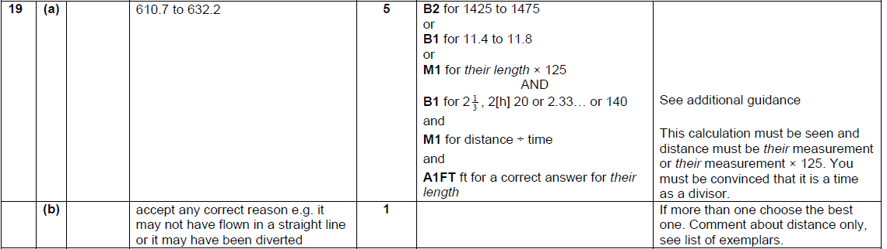

OCR Thursday 7 June 2018 – Morning (Non Calculator) Foundation Tier

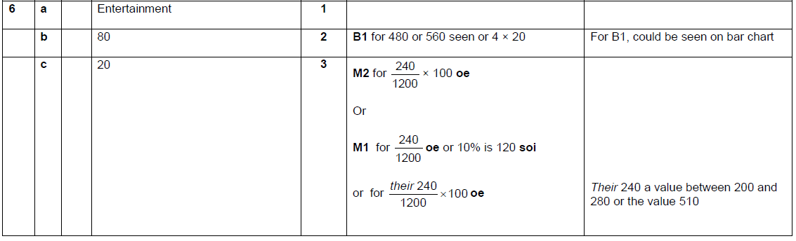

OCR Tuesday 12 June 2018– Morning (Calculator) Foundation Tier
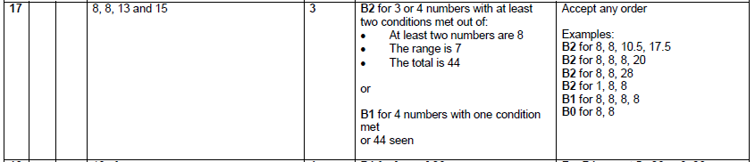

OCR Monday 6 November 2017– Morning (Calculator) Foundation Tier

Pearson Edexcel –Sample Papers - Paper 2 (Calculator) Foundation Tier

OCR Wednesday 8 November 2017– Morning (Calculator) Foundation Tier

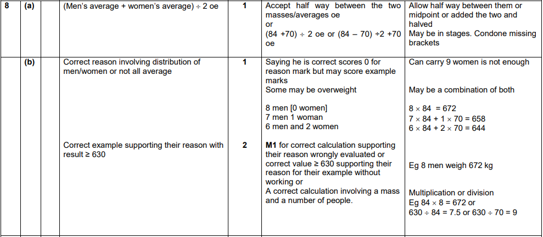
OCR Thursday 8 June 2017 – Morning (Non - Calculator) Foundation Tier

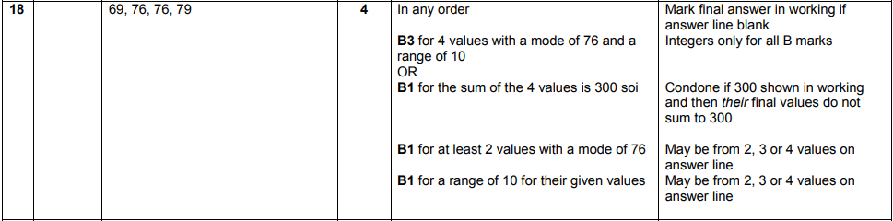
AQA Tuesday 19 May 2020 – Morning (Non-Calculator) Foundation Tier

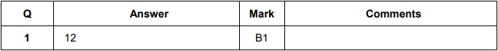
AQA Thursday 4 June 2020 – Morning (Calculator) Foundation Tier

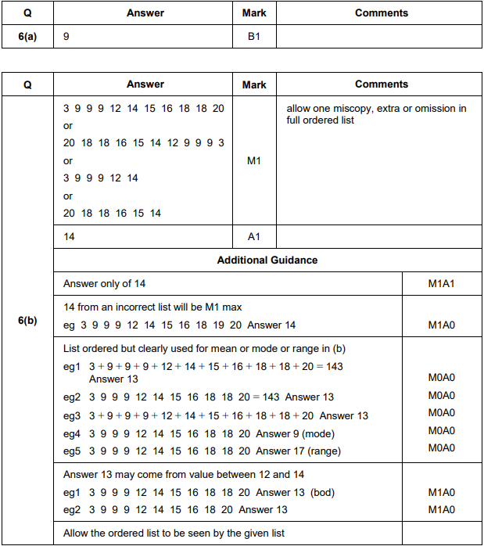

AQA Monday 8 June 2020 – Morning (Calculator) Foundation Tier

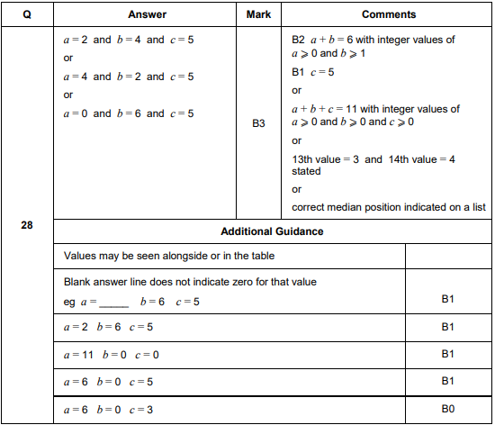
AQA Tuesday 6 November 2018 – Morning (Non-Calculator) Foundation Tier

AQA Monday 12 November 2018 – Morning (Calculator) Foundation Tier

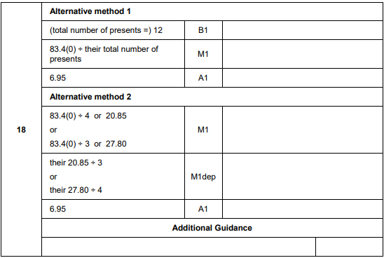
AQA Thursday 24 May 2018 – Morning (Non-Calculator) Foundation Tier

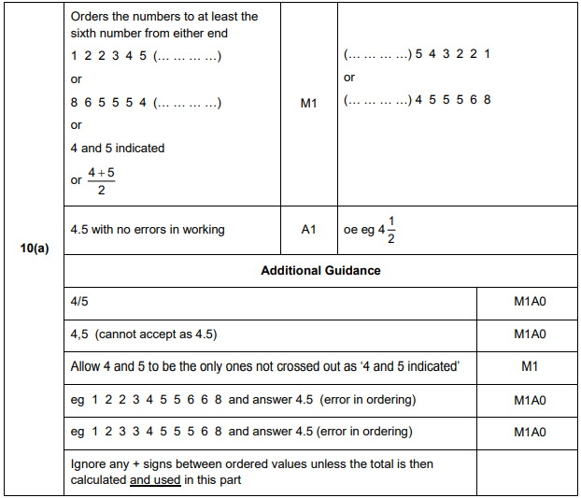
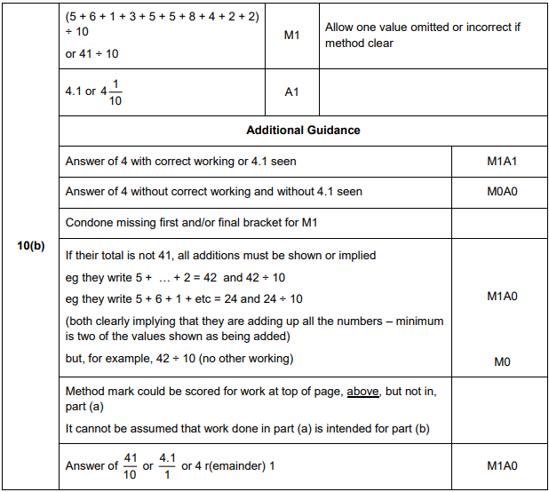
AQA Thursday 24 May 2018 – Morning (Non-Calculator) Foundation Tier

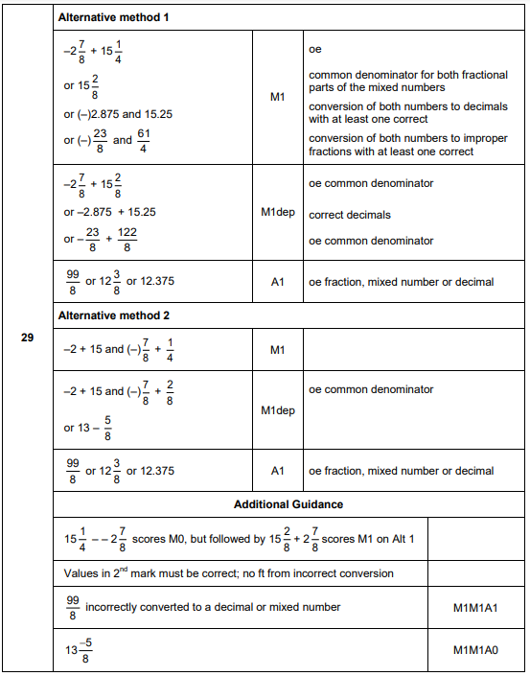

AQA Thursday 2 November 2017 – Morning (Non-Calculator) Foundation Tier

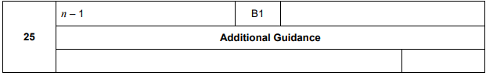
AQA Monday 6 November 2017 – Morning (Calculator) Foundation Tier

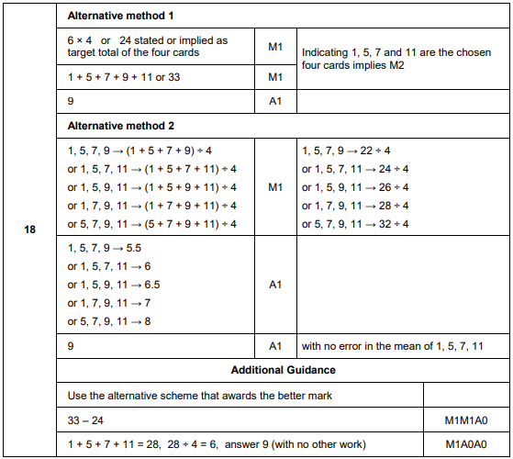

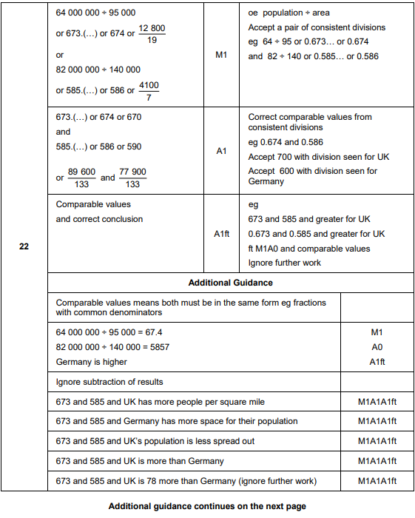
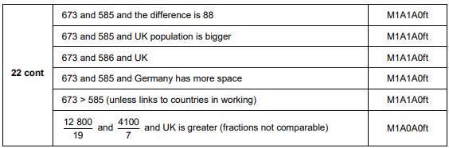

AQA Thursday 8 June 2017– Morning (Calculator) Foundation Tier

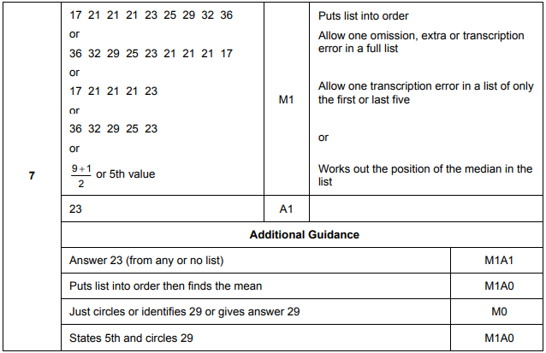

AQA Thursday 8 June 2017– Morning (Calculator) Foundation Tier

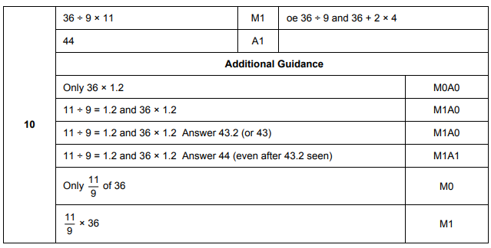
AQA Sample Paper 3– Morning (Calculator) Foundation Tier

